**Near Miss Field Experiment**

**Objective of the Experiment**

Testing the effectiveness of the proposed probabilistic hazard zone.

**Test Setup**

The test will be conducted in a parking lot or similar area. A traffic cone (representing a worker) with a sensor device (having GPS and IMU) will be placed at some position. A vehicle will then travel towards the cone at different speeds. The vehicle and the driver will also have a sensor device with GPS and IMU. Alternatively, the driver may have a notification mechanism that can fire an alarm based on the distance between the vehicle and the worker (the cone).

The driver will then start to react in a safe way once the worker is in the hazard zone and an alert is triggered. The final distance between the vehicle and the cone will then be measured to decide whether the vehicle managed to stop at a safe distance or not. This test will be repeated for different vehicle speeds and worker locations, and the number of true predictions and false alarm cases will be recorded for further analysis.



**Required Tools**

|  |  |  |  |
| --- | --- | --- | --- |
| Work item | Units | Quantity | Remark |
| Vehicle | Pcs | 1 |  |
| Sensor Devices | Pcs | 3-8 | More number of devices will allow different worker positions to be tested at once |
| Traffic cone | Pcs | 1-6 |  |

**Preparation Works**

**Sensor Installation:** Sensor Installation on traffic cone and vehicle including designing attachment mechanism and deciding on the location of installation.

**Sensor Calibration and Testing:** Evaluating how well the sensors perform for the different scenarios, checking and adjusting of any measurement drifts.

**Data:** Preparing data format showing the data to be recorded, the recording duration, and the data labeling procedure.

**Data Transmission:** Testing the reliability of data transmission from the sensors to computer. Identifying any signal disruptions, power issues, or limitations in wireless range.

**Camera:** Preparing camera for video recording.

**Test Scenarios**

The test will be conducted 25 time for 5 different speeds and five different worker locations. Worker locations will be varied across the width of the vehicle path with one location at the center and the rest on both directions away from the center.

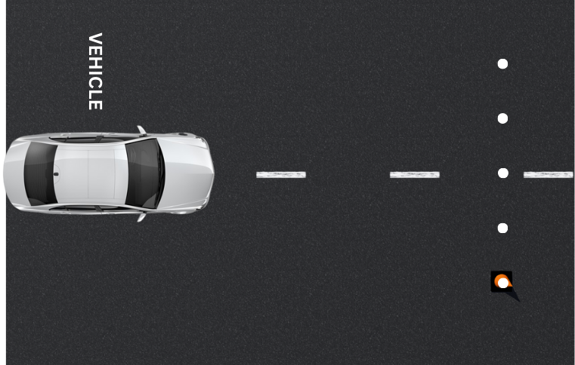

**Safety Measures**

**Safe Distance:** Ensuring all personnel are at a safe distance during vehicle intrusion tests.

**Signage:** Ensuring proper signage is used to indicate that a test is in progress.

**PPE:** Ensuring proper PPE is worn by all personnel.

**Documentation**

**Labeling:** All sensor devices, traffic cones, and scenarios will be labeled and data will be stored in folders with the specific label names.

**Video:** All the tests will be video recorded and the recorded videos will be stored in the labeled folders. Additionally, photos will be taken for demonstration.

Table 4. Labeling

|  |  |
| --- | --- |
| Item | Labels |
| Sensor devices | SD-01 – SD-08 |
| Traffic cones | TC-01 – TC-06 |
| Scenarios | S-1-L-1 – S-5-L-5 |
| Folder and videos | Same as the scenarios |